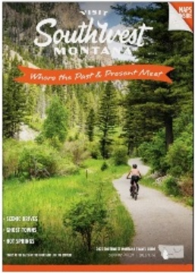

Business Name: Business Phone:
Address for Travel Guide: Listing City:
Contact: Email:
Mailing Address: Website:

For your Travel Guide listing, please SELECT which category (or categories) best describes your business.
You may select more than one (an initial listing is $150, while additional categories are $55 each).
*Under each category, check the services your business provides (no charge for services).

Categories & Services

____ Bed & Breakfast ____Vacation Homes, Condos & Cabins

____Hotels, Motels & Hostels
⃞ Breakfast ⃞ Restaurant ⃞ Grab & Go ⃞ Pool ⃞ Pets

____Private Campgrounds
⃞ Tent sites ⃞ Wi-Fi ⃞ RV sites ⃞ RV dump ⃞ Electricity ⃞ Showers

____Ranches & Lodges
⃞ Family Activities ⃞ Meal included ⃞ Fishing ⃞ Trail rides ⃞ Hiking ⃞ Minimum stay

____Guided Services, Fishing & Outfitters
⃞ Big game ⃞ Lodging ⃞ Waterfowl ⃞ Trail rides ⃞ Fishing ⃞ ATV rental ⃞ Float trips ⃞ Pack Trips

____Equipment Rentals
⃞ ATV/side by side ⃞ Bicycle ⃞ Paddle Boat/ Kayaks/tubes ⃞ Trailers ⃞ Snowmobiles ⃞ RV or Camp trailers

____Outdoor recreation ____Hot Springs & Water Parks ____Breweries & Taprooms
⃞ Horseback riding ⃞ Zipline

____ Retail, Tours & Museums
⃞ Art Gallery ⃞ History ⃞ Museum ⃞ Retail ⃞ Theater ⃞ Tours ⃞ Wildlife

First listing $150 = $150.00
Additional categories: $55 each x ___ =_________
Total $ ___________
P. O. BOX 28, DEER LODGE, MT 59722 | 406.846.1943
office@southwestmt.com | southwestmt.com Facebook.com/southwestmt | Instagram.com/southwestmontana

